Tuan Nguyen

Lab3 : Network Spell Checker

Program Description

The project is created a spell checker server to connect with multiple of clients. Indeed, gain experience with multi-threaded programming and the synchronization problem. First, I have a server main thread to take command line argument (name of dictionary file). If dictionary file not provided use the default dictionary. The program should take an argument as a port number which to listen for incoming connection. The server has two functions: one to accept and distribute connection request from client, anther to contract a log file of all spell check. When the server start, take in command line argument in the form ./serv port dict_name - If port or dict_name unspecified, use the default one - When server start, it load in the dictionary to an array - create socket descriptor to connect it with clients and push the socket to a queue - create a threadPool consists of multiple thread workers which will handle the jobs - create another separate thread to handle writing to logfile. I also have a worker thread to Deque the socket descriptor from the queue. Beginning read in words from user clients - check if match, echo the result back to both server and clients - push the results to the logqueue.

User enter choice:

1. ./server: run default dictionary and default port number 1111
2. ./server dictionary.txt : run dictionary.txt as dictionary file to check for spelling and default port number 1111
3. ./server dictionary.txt 8888: run dictionary.txt as dictionary file to check for spelling and new port number (8888), not default port.

Once user has done entering choice

-The user can open a new terminal and enter nc 127.0.0.1 1111 to run default port or 127.0.0.1 8888(new new port number) to run.

-After done type network address to connect, they can start type in a word to check for spelling. For example, enter : hello , on new line will print hello is correct. Type: helb will print misspell.

All word that entering from a new terminal will print in main terminal and save in log.txt file. The user can maximum opened at most 4-new terminal that represented the number of client that can connect to the server. If the user opened the 5th terminal represent the 5th client to serve, the main terminal will print wait until another client or terminal exit the server. Moreover, the user can open 4 terminal and type in the word to spell check at the same time. The word will all be save in log.txt file and print to the main terminal.

To run:

cd lab3-1

make

enter: ./server or ./server dictionary.txt or ./server dictionary.txt (newportnumber: 8888)

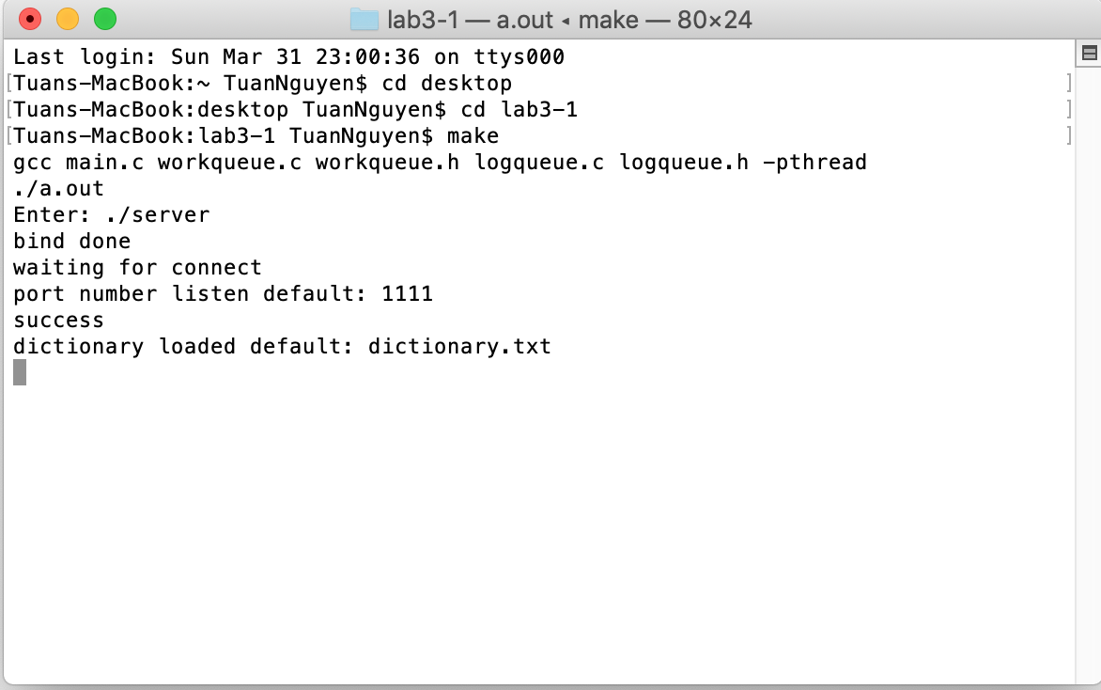

Open new terminal

type: nc 127.0.0.1 1111

The user can begin type in word for spell check